# EE565 TERM PROJECT

İbrahim GÜNGEN

1936939

METU-EE

## Part 1

5 Hp, 3-phase, 4-pole, Y-connected 230 V, 60 Hz motor

r1= 0.531 Ω r’2= 0.408 Ω X1=X’2= 2.52.mH Lm=84.7 mH J=0.1 kg-m2

External inertia= 1.0 kg-m2

Trated = Prated/Nr

Nr = 60*60/pole_pair, pole_pair = 4/2

Nr = 1800rpm

Wr = 1800/60*2*pi = 377rad/s, Trated = 5*746/377 = 9.9N

### 

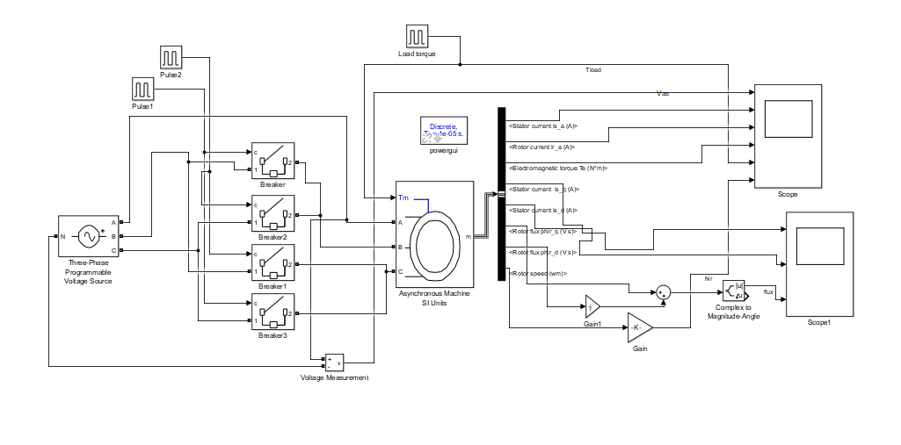

Figure 1. Circuit of part a.

For this part, first of all, motor is driven no load then rated torque is applied. And then, by using circuit breakers, phase B and C voltages are changed, so motor is operated reverse direction. Lastly, applied load is removed.

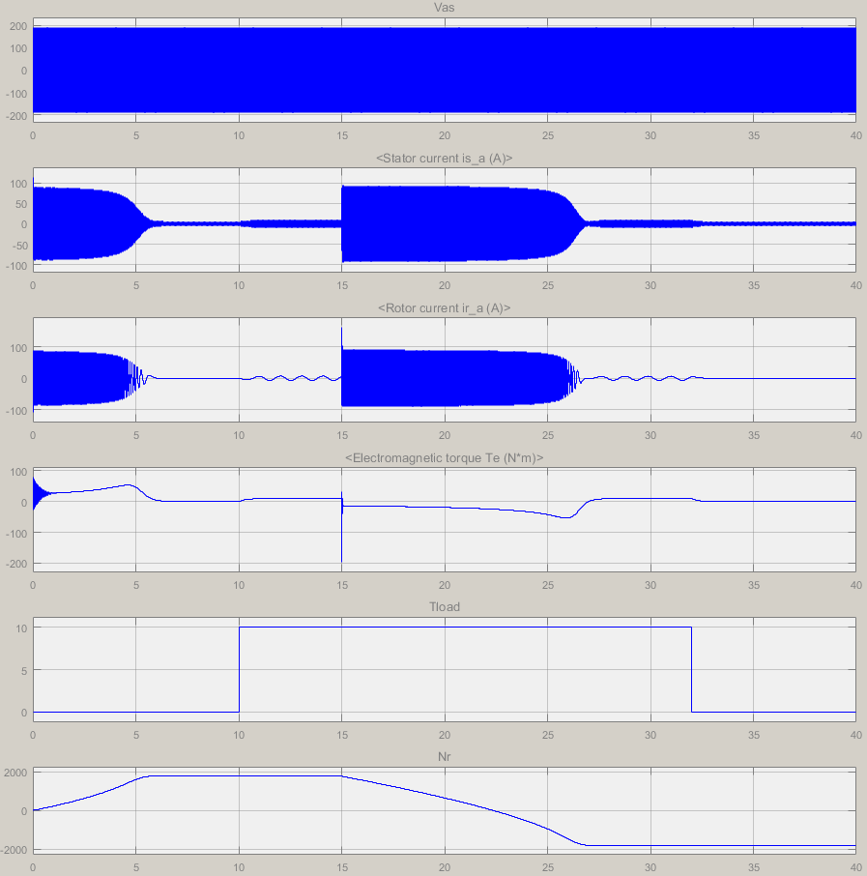

Figure

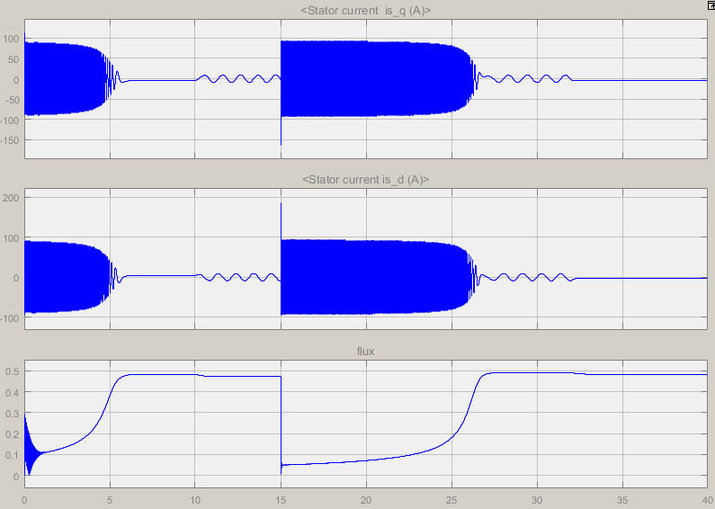

Figure

#### vi. and vii.

When motor is accelerating isd and isq is increase and rotor flux is decrease. When motor reaches rated speed flux become maximum. Also at reverse speed same behavior is observer because there is a magnitude of the flux I have drawn.

## Part 2

In this part I have tried 2 different control methods one of them is controlled by speed and torque by using CRPWM. At other one, Speed is controlled by iqs reference, I don’t implement controller for speed and torque by using voltage source inverter. I would like to explain first one and also, I give a brief for other one.

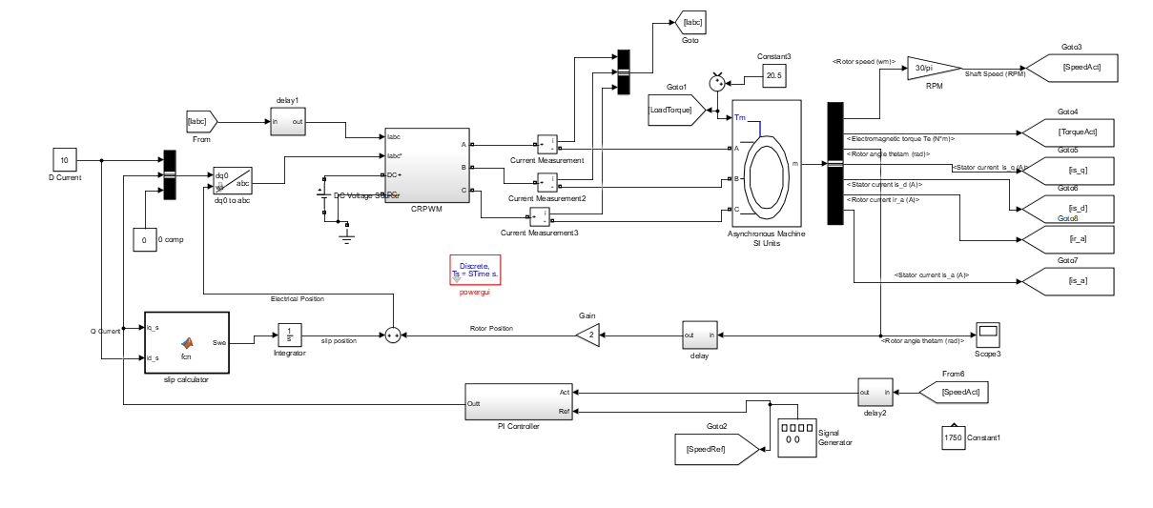

Figure

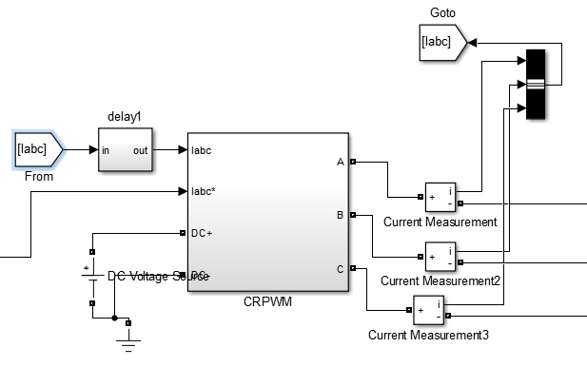

Figure

By using current regulator and universal bridge Current Regulated PWM inverter is designed, then gave 380Vdc and actual 3 phase current values and calculated reference current values are given as an input. Reference current values are came from 2phase to 3 phase transformation.

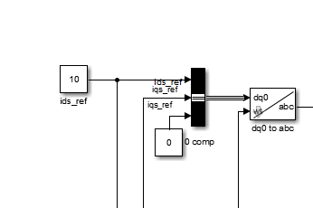

Figure

At figure 6, transformations of currents are shown. İds is related by flux and also it effects torque and acceleration so that I have chosen it as 10. Iqs is output of the PI controlled which controls speed of the motor. Also wt is calculated from slip calculator and rotor position.

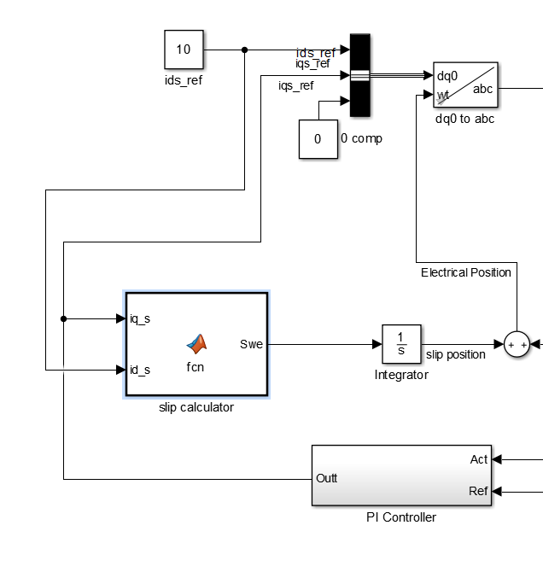

Figure

By using calculated iqs and referred ids slip is calculated, and then electrical position of the motor is obtained for transformation.

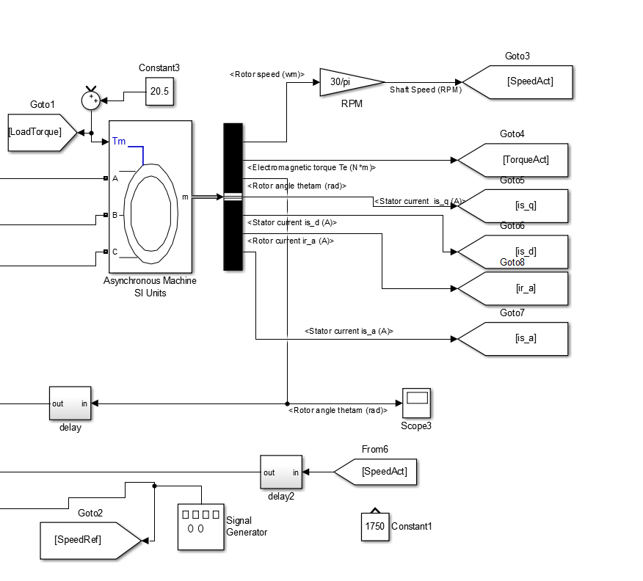

Figure

Motor block of the design is shown as previously.

Also I have used reference speed value according to the twice of the rated torque which is leading to the approximately 1740 rpm. This is calculated from relation of slip and torque.

### j. and k.

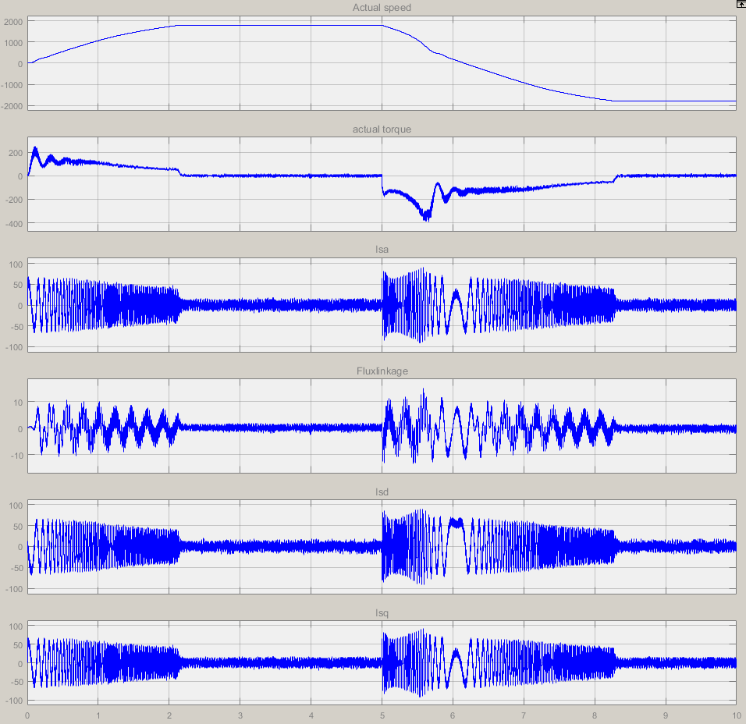

Figure . No load condition graphs

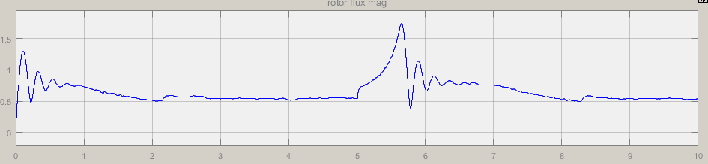

Figure . No load condition graph of flux

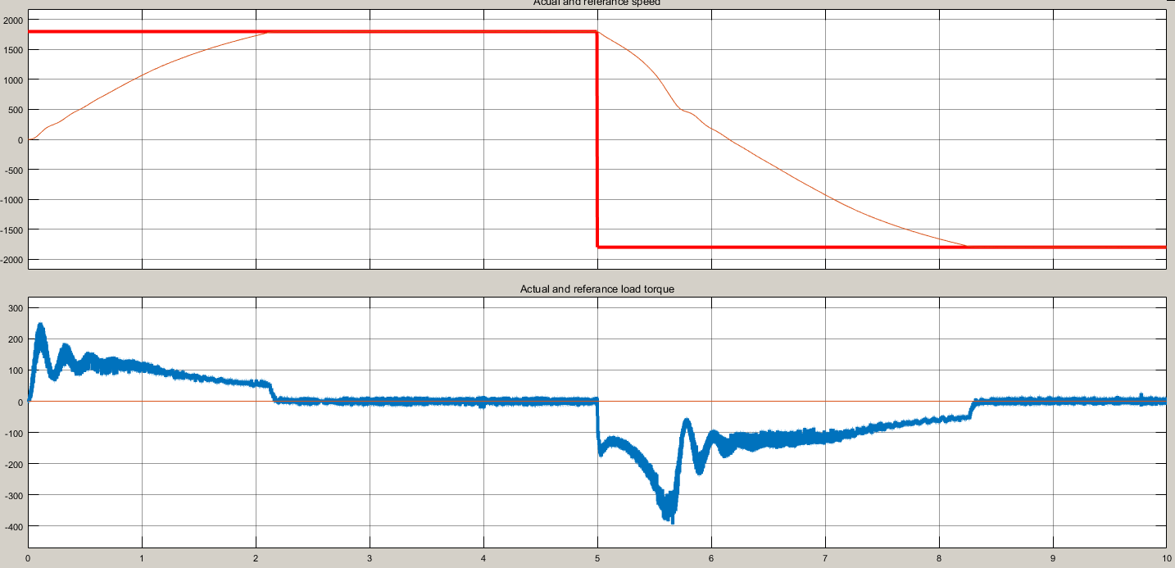

Figure . No load speed and torque

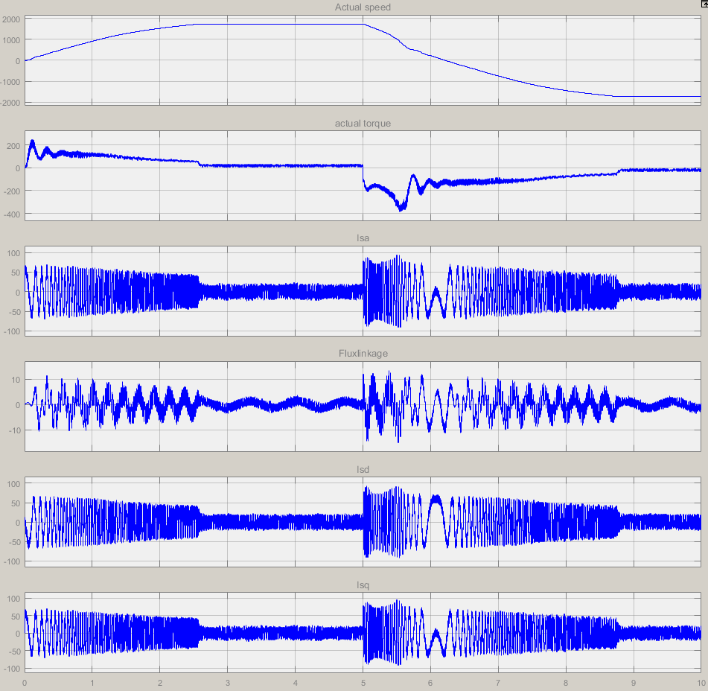

Figure . graphs for twice of rated load

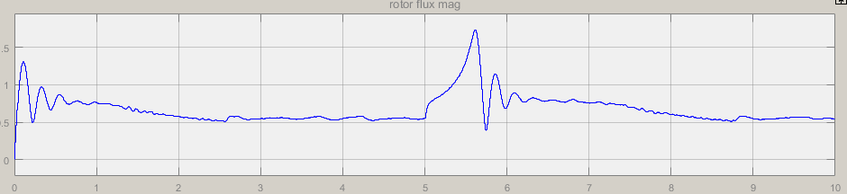

Figure . flux graph for twice of rated load

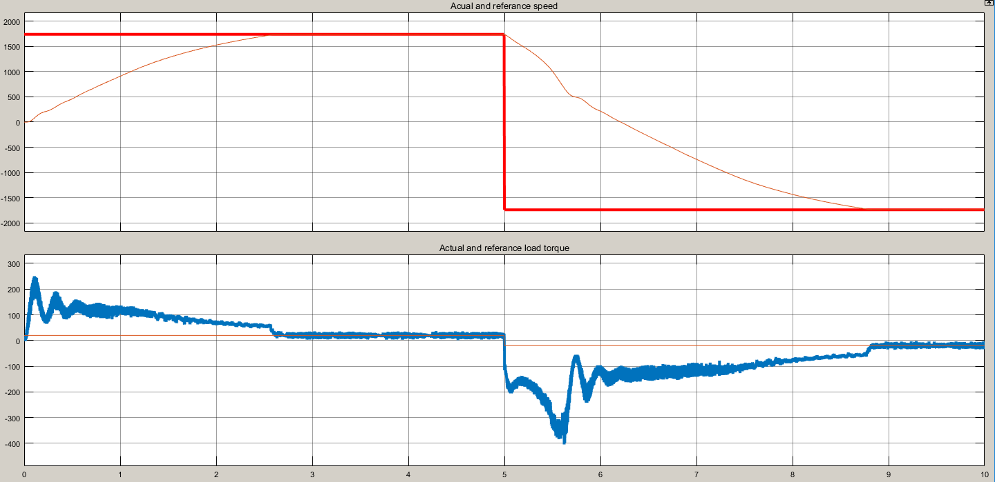

Figure . graphs for twice of rated load

#### vi and vii

Flux is controlled with vector control method and also stator current values are decreased although reaching rated speed time interval decreases. It shows that vector controlled is achieved. Moreover torque ripple decreased significantly.

Reaching time for reverse rated speed is decrease a lot. Ripple of torque and current decreased.

With load speed of reaching time increase and also electrical torque values increase a little bit. Also, other values are almost same with no load condition.

### 

|  |  |  |
| --- | --- | --- |
|  | Non- vector control | Vector control |
| Acceleration time | 5s | 2s |
| Torque oscillation time | 1.5s | 0.5s |
| İas oscillation peak value | ~100Apeak | 55Apeak |
| Reverse speed acceleration time | 12s | 4s |

## Appendix

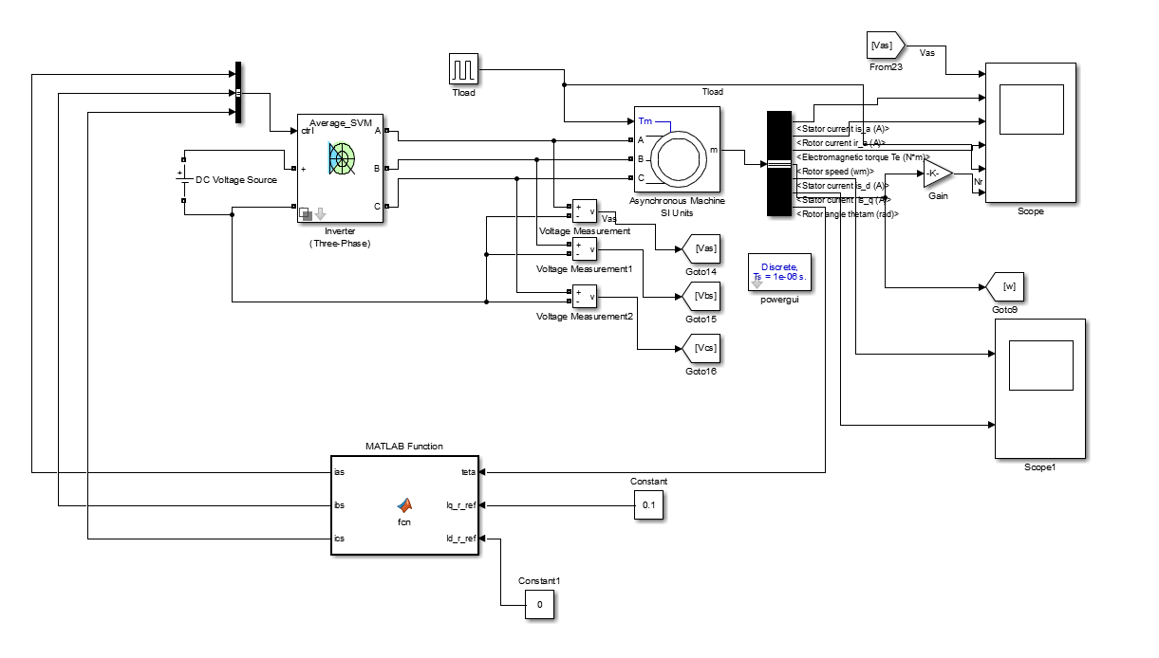

At this method, I have tried to make project without current regulated inverter it achive a little but I have some mistaken for this one.